**PROJECT TITLE:**

* Social Distancing Alerting System.

**INTRODUCTION:**

**Overview:**

In the fight against the COVID-19, social distancing has proven to be a very effective measure to slow down the spread of the disease. People are asked to limit their interactions with each other, reducing the chances of the virus being spread with physical or close contact.

**Purpose:**

To ensure social distancing protocol in public places and workplace, I have developed a social distancing detection tool that can monitor if people are keeping a safe distance from each other by analyzing real time video streams from the camera. For example: People at workplaces, factories, shops can integrate this tool to their security camera systems and can monitor whether people are keeping a safe distance from each other or not.

**RESULTS:**

1. **Screenshot of flask app:**

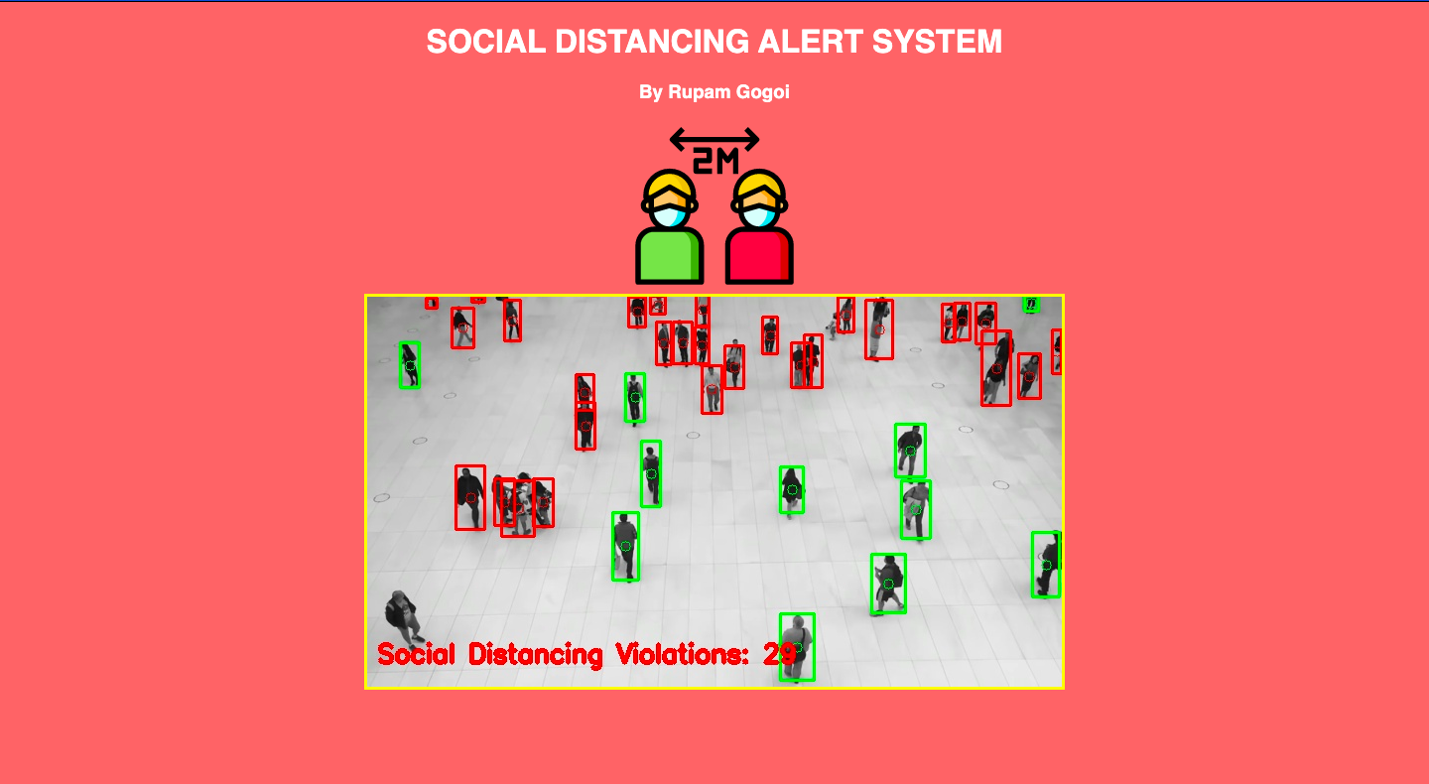

1. **Screenshot of input video 1:**

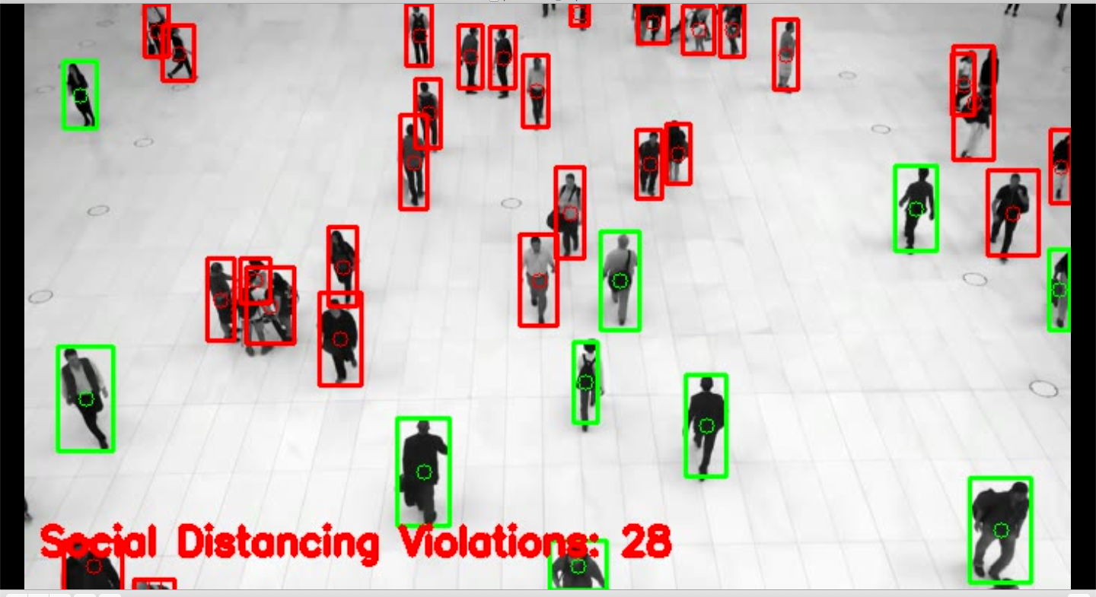

1. **Screenshot of input video 2:**

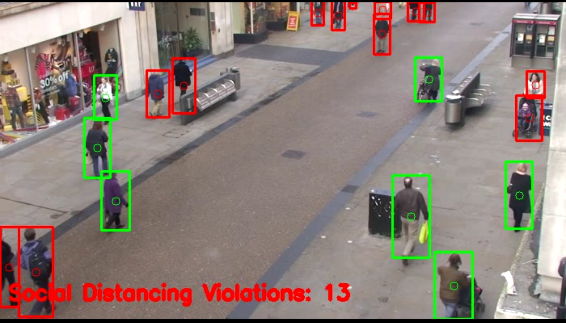

**APPLICATIONS:**

## **Airports**

Social Distancing AI App can be used at airports to identify if people are maintaining social distance or not. Multiple IP cameras installed at the airport can capture people standing in close proximity and logs are kept in a system. The app triggers the voice alerts and sends notifications to the concerned authorities.

## **Hospitals**

Hospitals can use social distancing apps to monitor if people are adhering to social distancing or not. Using CCTV cameras installed at hospital premises, health authorities can track if visitors, patients or health workers are maintaining a distance or not. If somebody is found violating the distancing, alerts will be sent to the concerned authorities to take action.

## **Offices**

The risk of COVID-19 will not be ending soon; therefore, offices after the lockdown can use this app to ensure that social distancing is maintained until the risk of COVID-19 does not go away. Offices can add face data of their employees and if anyone is found not following distance can receive an alert or notification.

## **Manufacturing plants**

Social distancing alert devices can be used in manufacturing plants to prevent workers from the risk of infection. IP or CCTV cameras installed at the plants would capture and identify if workers are found in close contact with each other. Notification alerts will be sent to the concerned workers and their authorities.

## **Retail shops**

Retail stores can use the social distancing AI app to ensure that visitors maintain a specific distance from each other. Cameras connected to the app would track the in-store activity and trigger voice alert to aware people. Also, retail stores can integrate a plugin into their website or app to display the live count of visitors in the store so that people can visit the store when the count is less and there is no risk of infection.

## **Schools**

Using a social distancing AI app, schools can manage social distancing efficiently. If students or teachers are found violating the distancing within school premises, an alert is raised and notification is sent to concerned authorities.

**CONCLUSION:**

This solution can integrate with enterprise applications to provide global enterprise health & safety visibility. The detection system is non-invasive to privacy, contact-less, and provides quick responses to enterprise stakeholders. This system can be easily deployed, operated, managed, and supported.

**FUTURE SCOPE:**

* Reduce the number of infections and transmissions.
* Safe guard work-spaces and working environment.
* Improve business operational efficiency & productivity.
* Adherence to social-distancing & protection compliance.
* Reduce queuing at public and private business entrances.
* Better decision making through analytics and visualization.
* Real-time global visibility for enterprises.

-----------------------------------*****************-----------------------------------